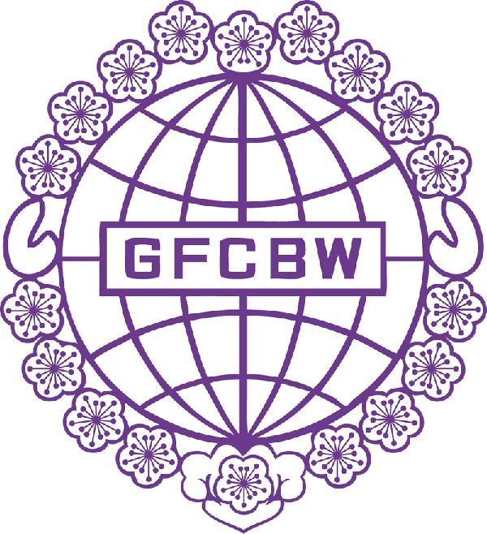
世界華人工商婦女企管協會
亞特蘭大分會
GFCBW Atlanta Chapter

個人會員入會申請書
Individual Member Application Form

姓名  NAME | 中文 |  | 申請日期  APPL.DATE
 | English |  | 出生日期  BIRTHDAY
通訊地址
ADDRESS
公司名稱  COMPANY | 中文 |  |  | 職稱  POSITION |  | 中文
 | English |  |  |  |  | English
電話  PHONE |  |  |  | LINE ID
郵件信箱
EMAIL
社團及事業經歷Processional Experience/ Community Service
推薦理事:  Referred by Board Member |  | 推薦理事或會員:  Referred by Board Member or Member
- 本人同意參加貴會為會員並願遵守貴會之章程。
I Agree to be a member of GFCBW and to follow the articles of this federation.
- 本會年費：個人會員每年美金一百元整。會費請開支票抬頭: GFCBW-Atlanta
Annual membership fee：For individual member is US$100 per year. check payable to GFCBW-Atlanta
- 個人會員：凡年滿21歲，不論其國籍，贊同本會宗旨，認同中華民國(台灣)政府，並對工商經營有顯著貢獻之傑出華人工商婦女，經由理事及會員各一人推薦，經理事會通過，並繳納會費者，得為本會個人會員。Those women in business and career at least 21 years of age, who assent GFCBW principals and recognize Taiwan governing sovereignty, may submit membership application endorsed by one GFCBW-ATL board member and one member; she shall become a member upon approval of the board’s review,
- 請Email會員申請表至GFCBW.Atlanta@gmail.com
Send application form to above email address
申請人簽名：________________________ Date: ____________
心懷世界．掌握脈動．建立網路．發展經貿
Concern the world．Understand the trend．Set-up worldwide network．Develop commerce opportunities.

